|  |
| --- |
|  |
| User Guide |
|  |
|  |
|  |
|  |

|  |
| --- |
|  |

Contents

List of Figures 1

Running the Program 2

Main Screen 2

Instructions Screen 2

Starting a Game 3

Playing a Game 4

Starting Another Game 6

## List of Figures

Figure 1…………………………………………………………………………….……….2  
Figure 2………………………………………………………………...…………………...3  
Figure 3...……………………………………………………..…………………………….4  
Figure 4……………………………………………………………………………………..5  
Figure 5………………………………………………………………………………..……6  
Figure 6………………………………..……………………………………………………7  
Figure 7………………………………..……………………………………………………8

## Running the Program

To run the program, run the NaughtsandCrosses.exe.

Insert pic here of .exe

## Main Screen

When the program has been loaded the main menu screen will appear (Figure 1). This menu will allow the user to look at the instructions of the game and to start a new game. For now click the ‘Instructions’ button.

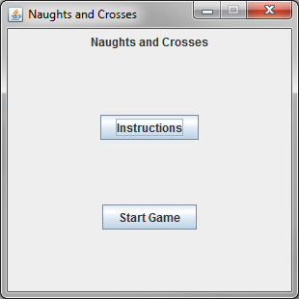

Figure 1

## Instructions Screen

The instructions menu (Figure 2) will appear and shows the rules of the game and how to win. Once you have read the information you can navigate back to the main menu by clicking the ‘<<Back to main menu’ button.

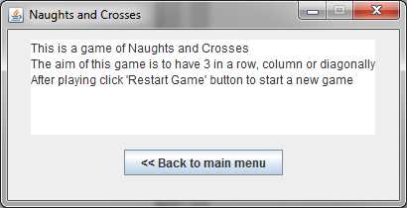

Figure 2

## Starting a Game

Now that we are back at the main menu (Figure 1) you can start a new game by clicking the ‘Start Game’ button. Once clicked the game screen should appear (Figure 3).

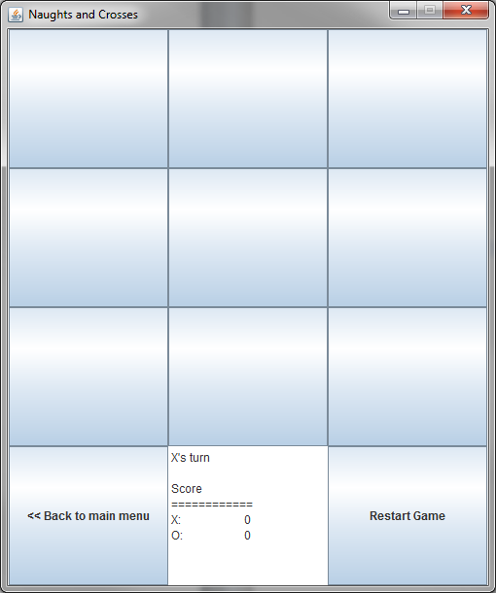

Figure 3

## Playing a Game

In this game the human player will always be ‘X’ and the computer player ‘O’. To play this game simply click an unmarked tile. An example is shown in Figure 4 where the human player has marked the centre tile and the computer player has responded by placing their marker in the bottom right tile. This will continue until a player has won or a tie as shown in Figure 5.

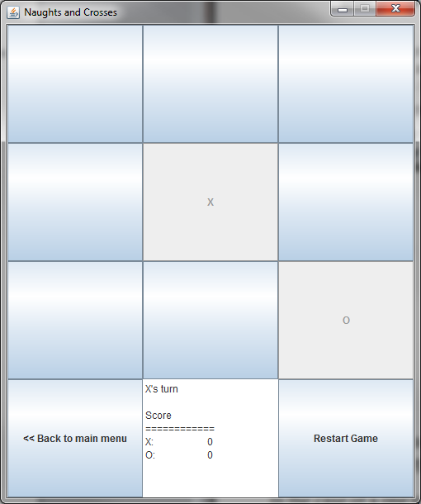

Figure 4

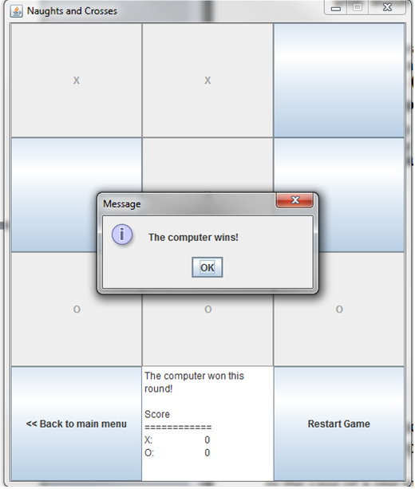

Figure 5

## Starting Another Game

After the message has appeared on screen and the user has clicked ‘OK’ the game screen will look remain the same as shown in Figure 6. This is due to a feature that allows the human player to, at any point of the game, return to the main menu screen (Figure 1), for example to navigate to the instructions menu, and back to the game screen without the game being affected. In order to start another game click the ‘Restart Game’ button which will reset the board (Figure 7).

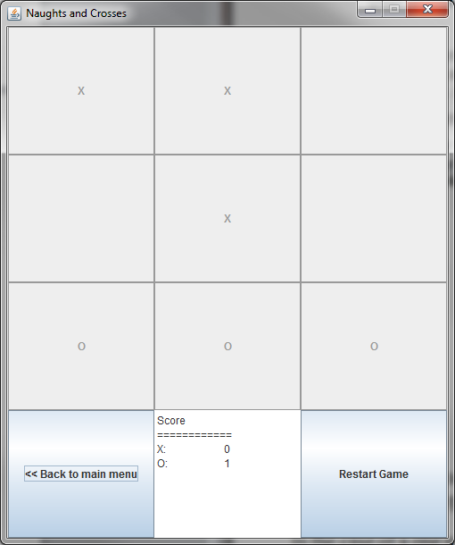

Figure 6

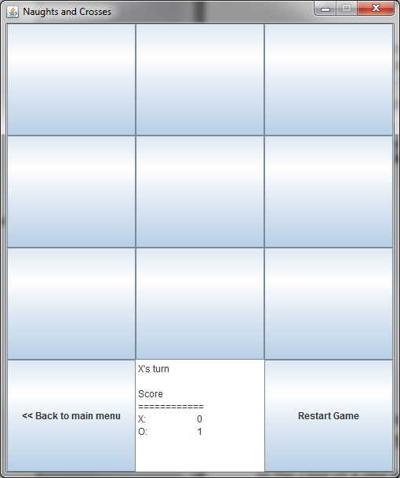

Figure 7